|  |  |  |
| --- | --- | --- |
| SCHOOL OF INFORMATION AND TECHNOLOGY | | |
| NAME: LARAYA, Althea Joy Y. | DATE PERFORMED: Sept 12, 2024 |  |
| Section: IDC2 | DATE SUBMITTED: Sept 12, 2024 |

# SYSADM1 – Managing Services in Linux

# Requirement:

* A virtual machine running Linux

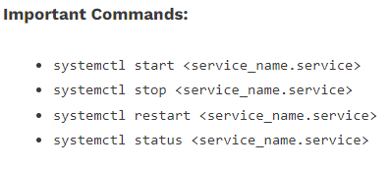

Complete this lab as follows:

Use the service –status-all command to list all active and inactive services.

List down active and inactive services in the table below. Provide five (5) services for each column.

|  |  |
| --- | --- |
| **Active** | **Inactive** |
| Alsa-utils | Anacron |
| apparmor | Bluetooth |
| apport | Console-setup.sh |
| Cron | Grub.common |
| cups | Keyboard-setup.sh |

SS:

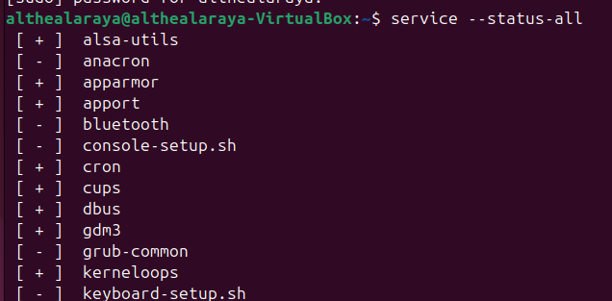

Start the Bluetooth service using the systemctl command.

Ex. sudo systemctl start httpd

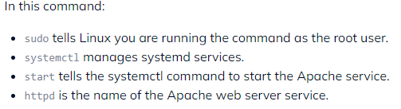



Check the status of the Bluetooth service. What is its status?

* + 1. Bluetooth needs a wireless connection before I can control its services.

SS: 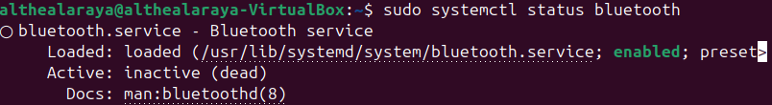

Check the status of the cups services. Since when was it running?

* + - 1. - Cups services was running since 09/12/2024 **8:47 AM**

SS:

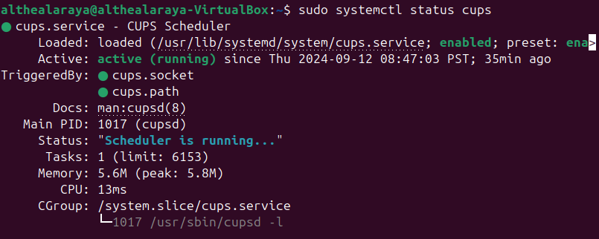

Stop cups services.

SS:



Verify if the service was stopped.

SS: 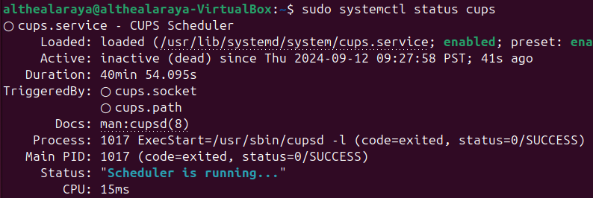

Restart the cups services

SS:



Verify if the service was restarted.

SS:

